Program No: Project | Date: 23-02-2026
Program Title: Predictive Modeling of Obesity Levels Based on Lifestyle and Dietary Habits: A Comparative Study using Orange Data Mining
@ Aakash Ninan Gikku
Roll no: Student 01
Obesity level analysis using orange

Objective of the Project
To analyze behavioral and physical data to predict a person's obesity category (e.g., Underweight, Normal Weight, Obesity Type I, II, or III) using classification models in Orange Data Mining. The goal is to identify which lifestyle factors—such as caloric intake, physical activity, and technology use—are the strongest predictors of weight-related health risks.

Dataset Description
- Dataset Name: Obesity Levels Based on Eating Habits and Physical Condition
- File Format: CSV (Comma-Separated Values)
- Total Instances: 1,689 (Training), 422 (Test) — Note: This assumes an 80/20 split of the standard 2,111 row dataset.
- Target Variable: NObeyesdad (Obesity Level)
- Attributes: Gender, Age, Height, Weight, Family History of Overweight, FAVC (High caloric food consumption), FCVC (Vegetable consumption), NCP (Number of main meals), CAEC (Consumption of food between meals), SMOKE, CH2O (Water intake), SCC (Calories monitoring), FAF (Physical activity frequency), TUE (Time using technology), CALC (Alcohol consumption), MTRANS (Transportation used).

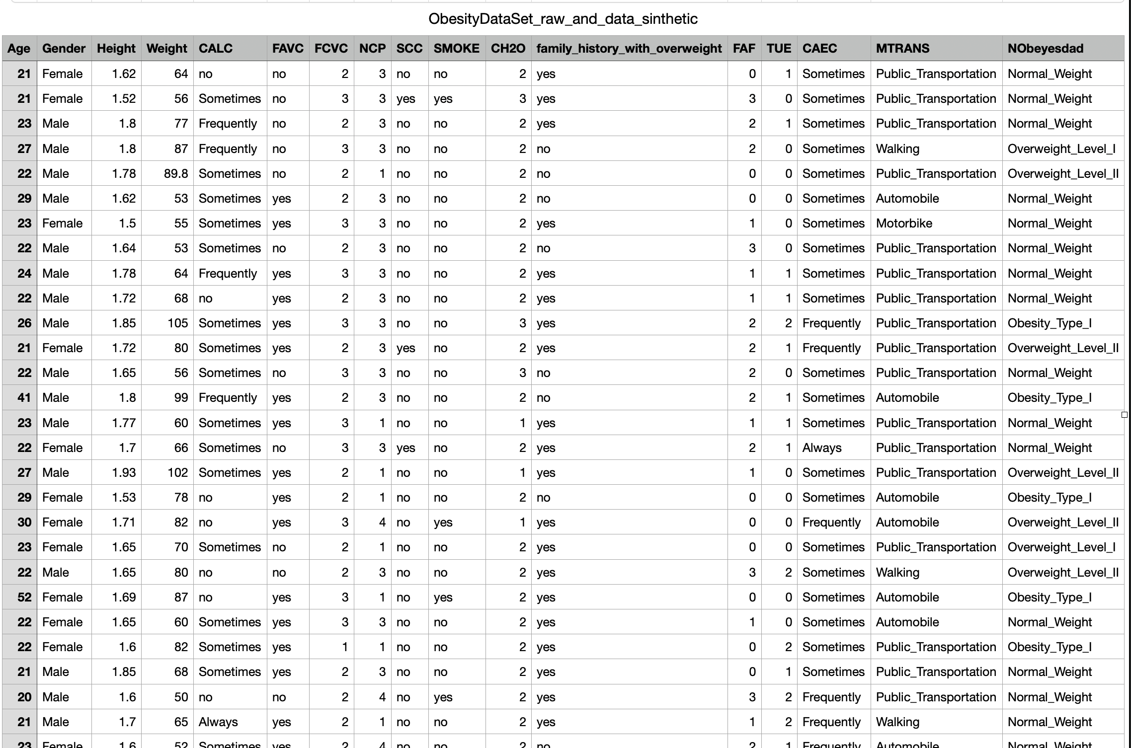

Data Preprocessing
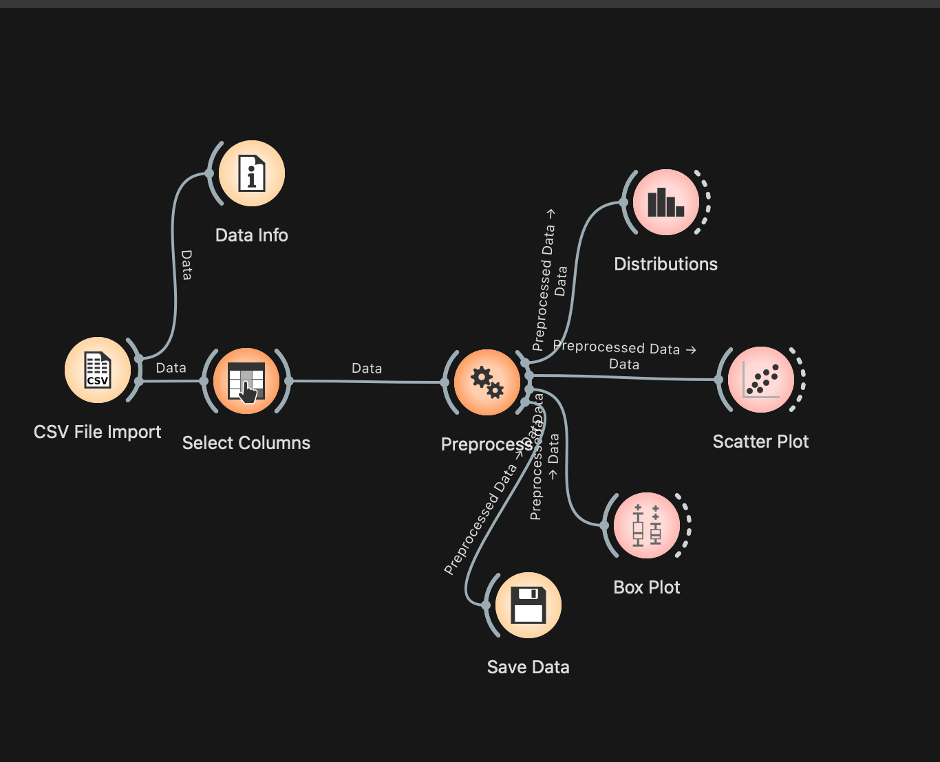
- Data Loading: Loaded the Obesity Levels dataset using the File widget in Orange.
- Target Variable Selection: In the Edit Domain widget, designated NObeyesdad (Obesity Level) as the target variable for classification.
- Data Quality Check: Verified the dataset for missing values and handled any inconsistencies to ensure the reliability of the feature set.
- Preprocessing & Encoding: Categorical attributes such as "Family History of Overweight," "Consumption of food between meals (CAEC)," and "Gender" were automatically encoded into numeric values using the Preprocess widget to make them compatible with machine learning algorithms.
- Feature Normalization: Applied Standardization (z-score) to numeric attributes like Age, Height, and Weight. This ensures that variables with larger numerical ranges do not dominate the model training process compared to smaller-scale variables.

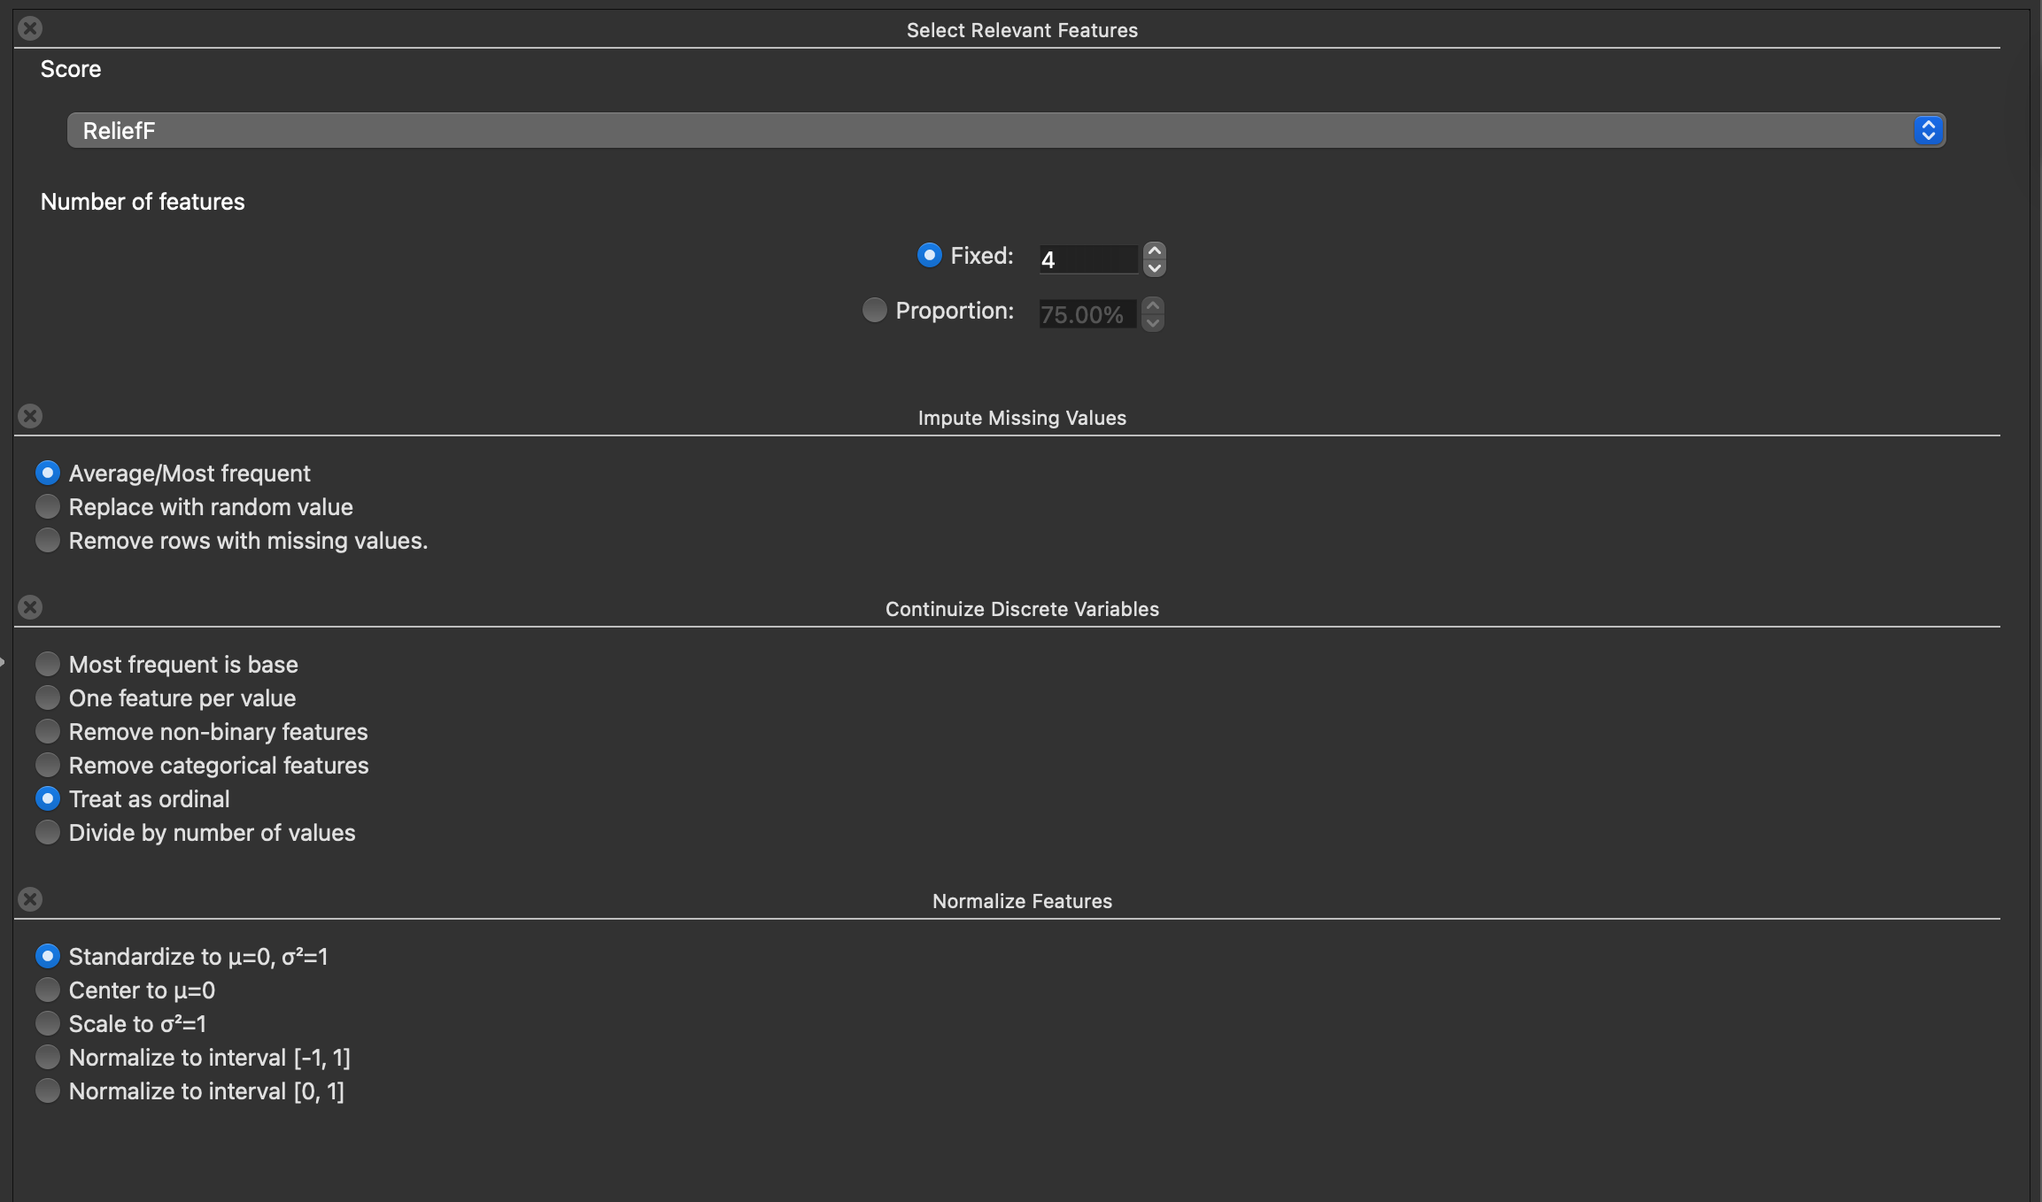

Data Visualization
- Used Box Plot to analyze the distribution of Weight (or BMI) across different Obesity Levels (NObeyesdad). This helped identify the median weight and variance for each health category.

- Used Scatter Plot to visualize the relationship between Age and BMI. This allowed for the observation of how weight categories cluster and whether specific age groups are more prone to higher obesity levels.
- Used Distributions to observe the frequencies of key lifestyle and dietary attributes, such as Physical Activity Frequency (FAF) and High Caloric Food Consumption (FAVC), to understand the general habits of the sampled population.

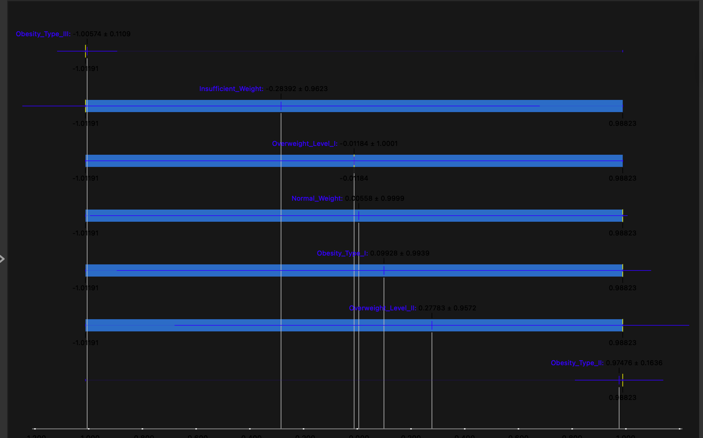

Model Building
- Split the dataset into training and testing sets using Data Sampler.
- Built the following classification:-Decision Tree,KNN,Random Forest

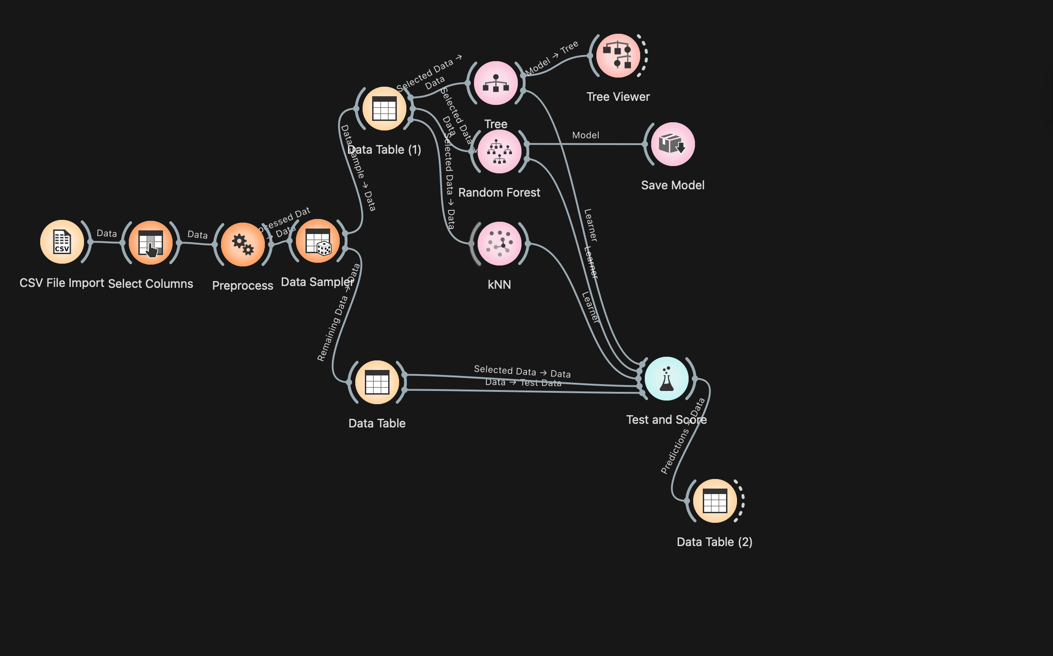

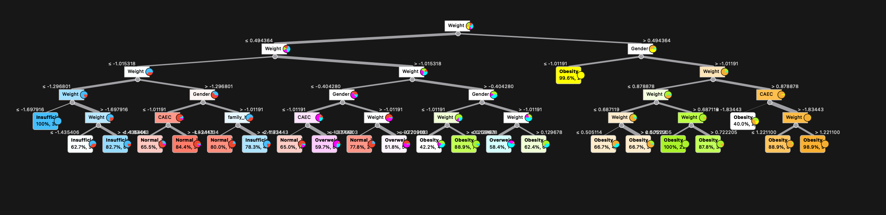

Model Evaluation
- Evaluated all models using the Test & Score widget.
- Compared models based on accuracy and other performance metrics.
- Random Forest was identified as the best-performing model.
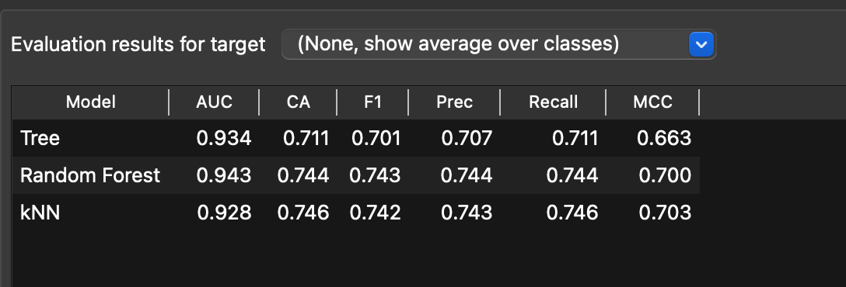

Prediction
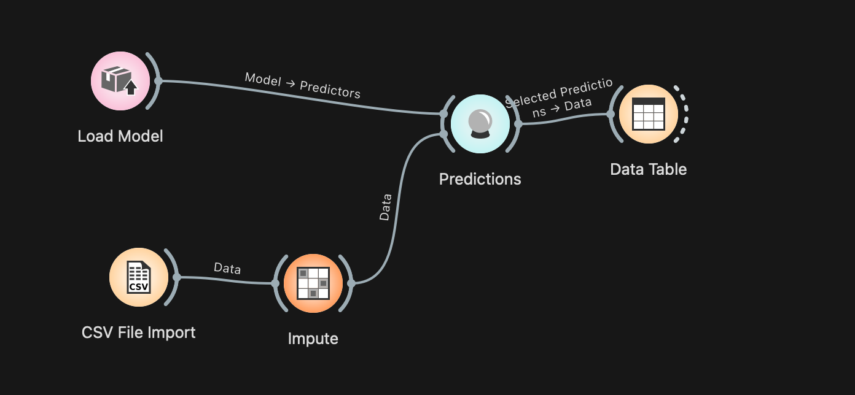

- Saved the best model (Random Forest) using the Save Model widget.
- Loaded the model using Load Model.
- Applied the model to an unknown dataset.
- Viewed predicted results using the Predictions and Data Table
- widgets.
